Technical Documentation

Contents Page

1. **Introduction pg. 2**
2. **Aim of the Program – pg. 2**
3. **How does the program work? – pg. 2**
4. **List of Features – pgs. 3 to 6**
5. **Block Header with Comments – pgs. 7 to 9**
6. **Data Declaration – pg. 10**
7. **Evaluation – pgs. 11 to pgs. 12**
8. **Further Improvements – pgs. 13**

**M4 -** Create technical documentation for the support and maintenance of a computer program

**Introduction**

In this report, I will create a technical documentation explaining my program. The purpose of this documentation is to explain step-by-step to other programmers. If another programmer were to make any corrections, he/she would ask for the technical documentation. I am also going to evaluate the application too for criteria D2.

**‘The Plumbing’ service**

**Goal of the application**

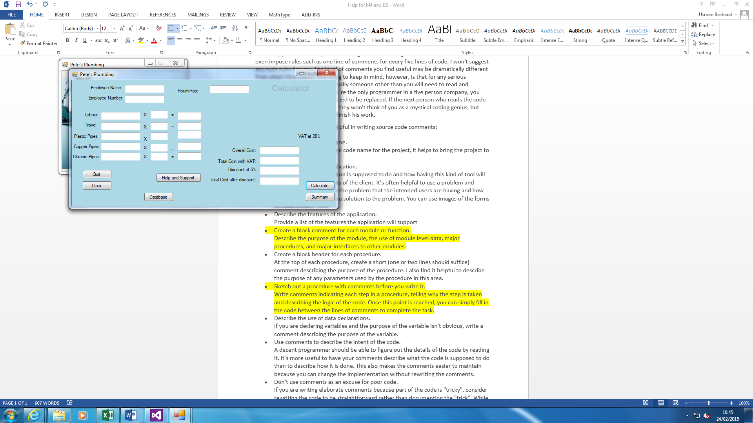This system was designed to erase errors for the plumbing service. It offers many services for the user to be comfortable with the new system. The current problem that the plumber faces is that there are often errors in his calculations; which have resulted in him carrying out work for very small profit, and sometimes losing work because his estimate was too high. It helps out sort everything. The picture below shows what it does. All you do is type fill in the blank spaces and it does it for you.

**How does the program work?**

1. Open the program up. Wherever it is located, you need to find it and open it up.
2. Enter Username and Password
3. Enter all calculations
4. Click the ‘Calculate’ button once finished
5. Reset by pressing ‘Clear’ button
6. If any support needed, click ‘Help and Support’ button for any assistance
7. Exit the application by clicking ‘Quit’ button
8. If any printing to be done, click ‘Summary’ button and then print

**List of Features**

**Clearing**

Clearing button shows us that you can restart the whole calculations if there is any errors. The code below shows that all of them are cleared.

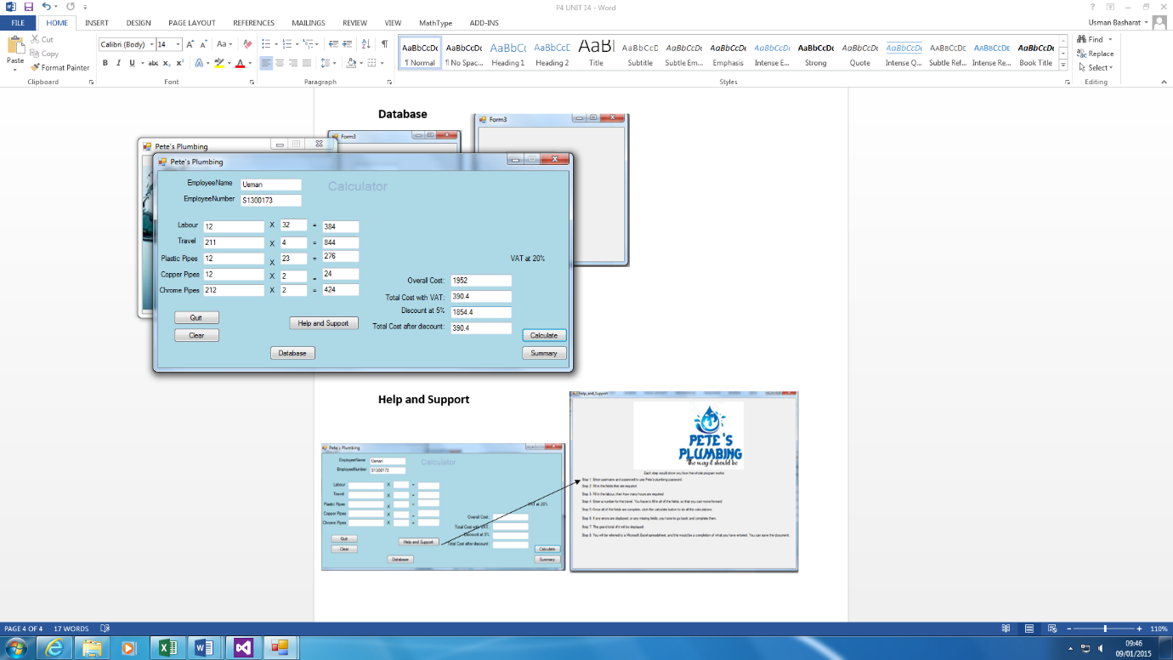

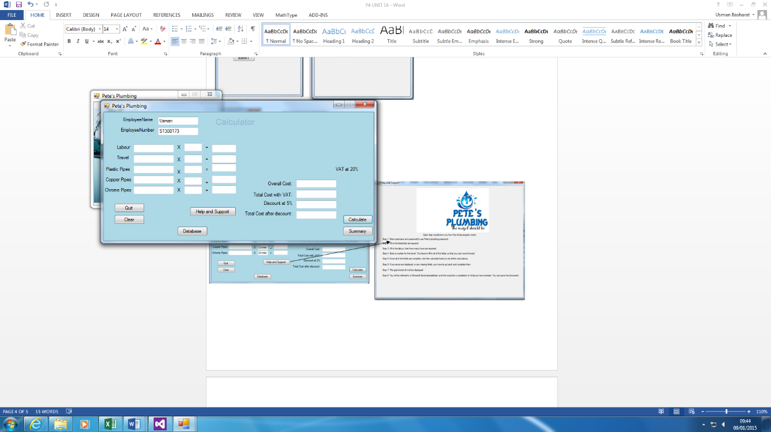

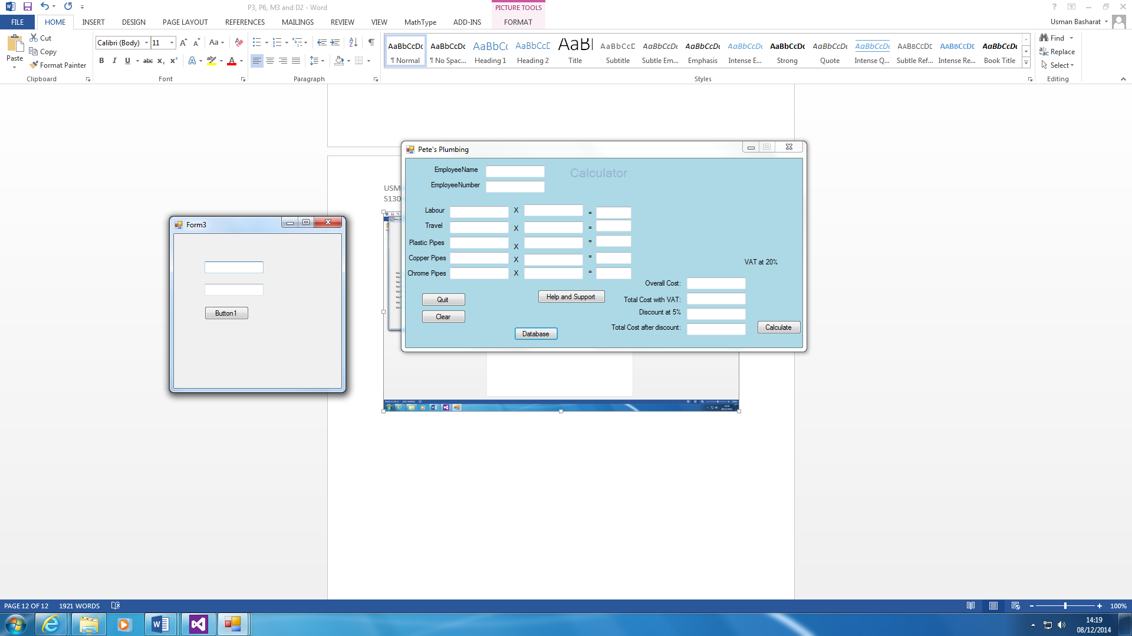**Database**

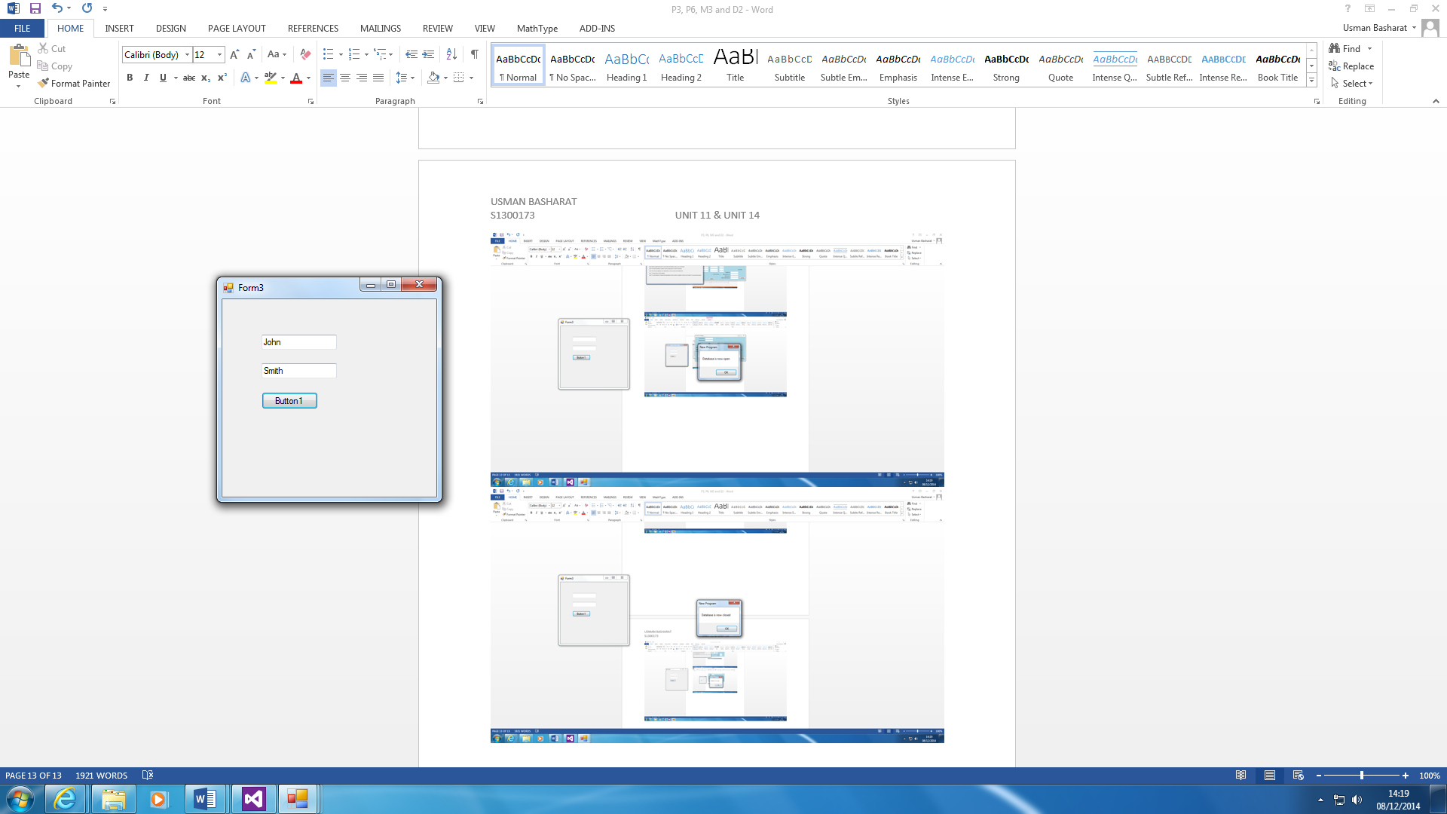

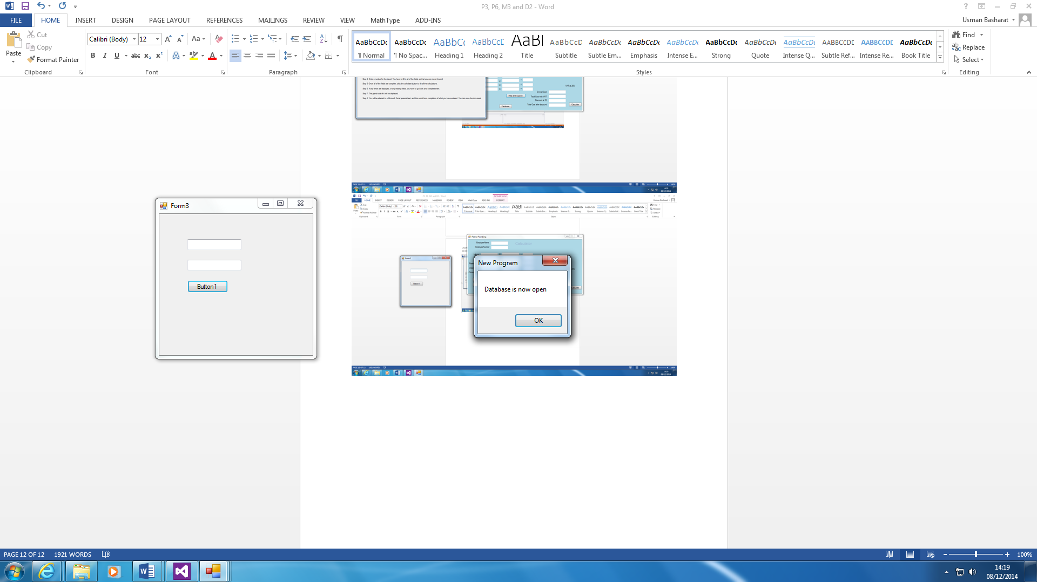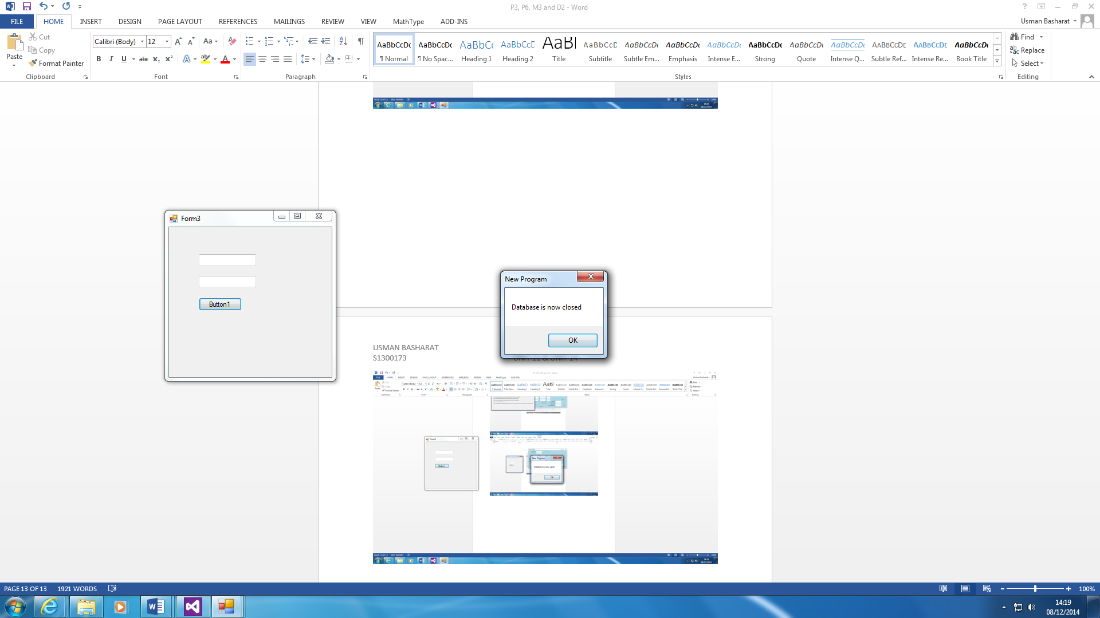

This database is made that can be used for several other reasons, but I chose to do this because it shows the connection between the two. The code instructs how it is complete. Firstly, the user needs to click the button. Once this is complete, the information is brought from the database. It gets the information, and it fills it in within the two boxes. It can be used for the Login Screen as well. Therefore, they are many benefits for its use.

**Calculate**

This is the part where the user needs to fill in for the calculations to be complete. This will erase any issues that the user is having currently.

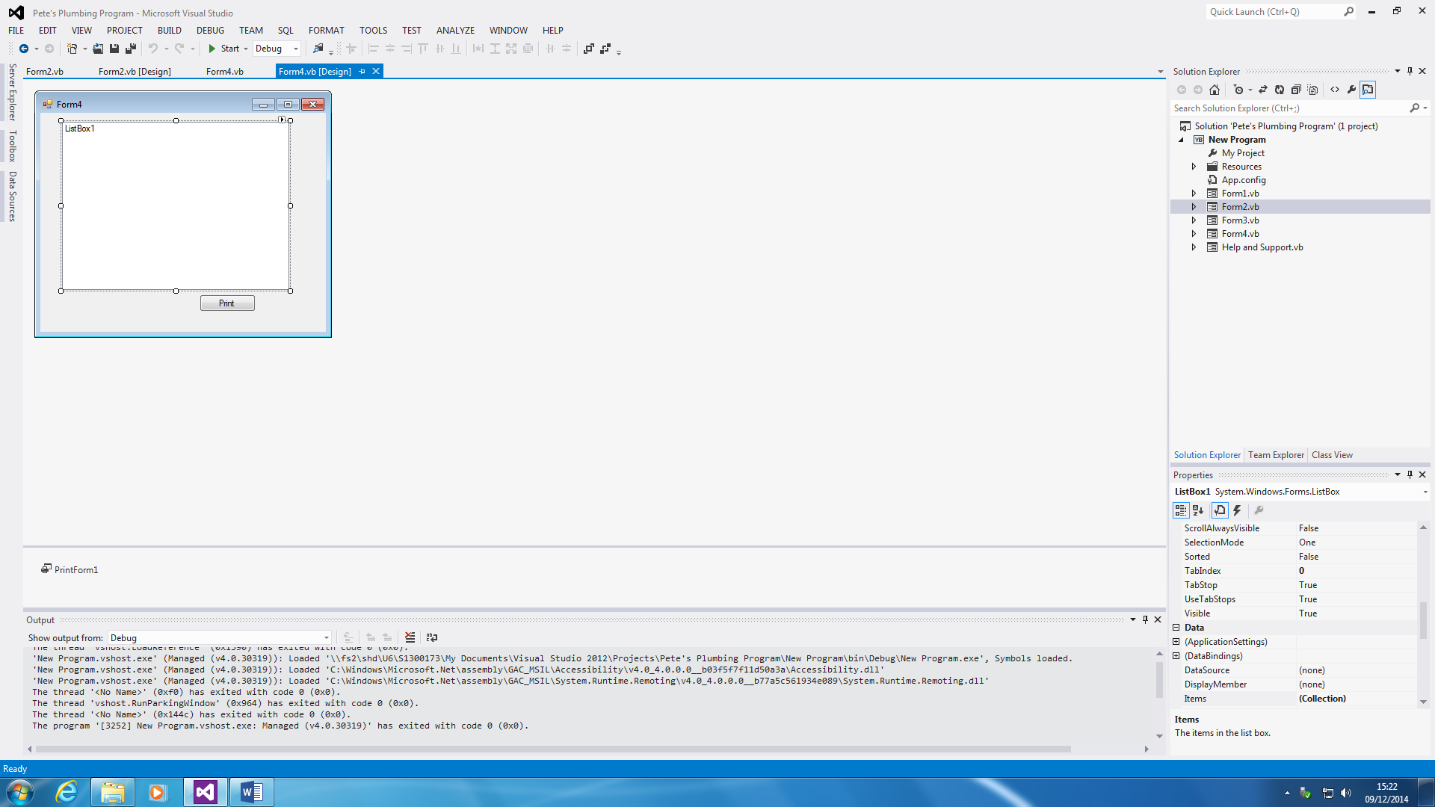**Summary**

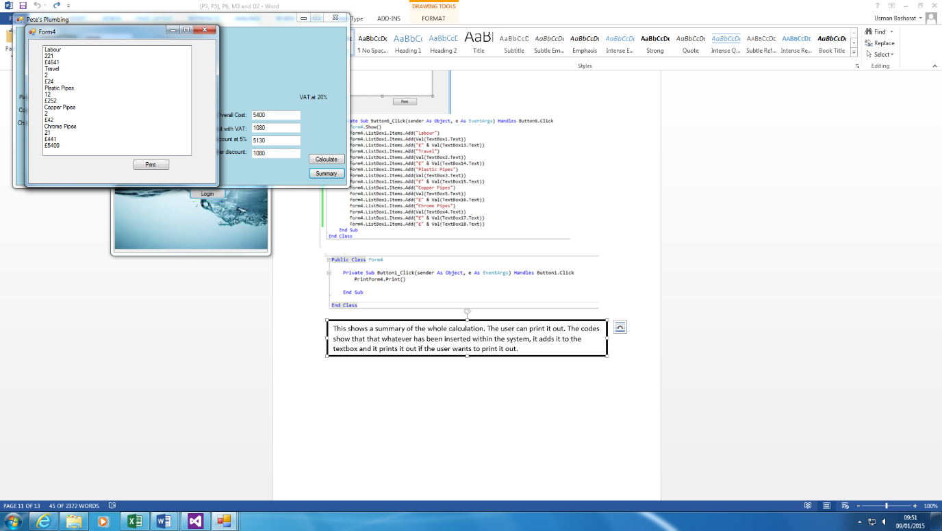

This shows a summary of the whole calculation. The user can print it out. The code above shows that whatever has been inserted within the system, it adds it to the textbox and it prints it out if the user wants to print it out.

**Help and Support**



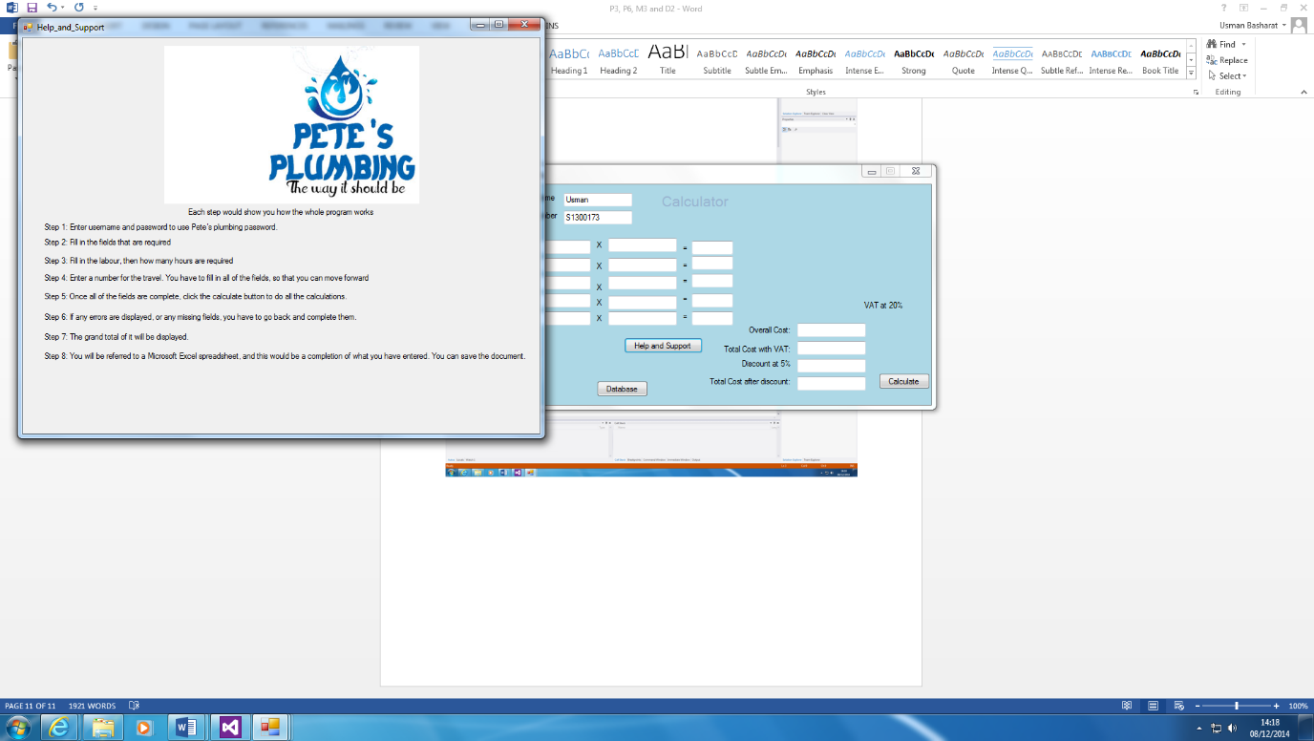

Help and Support button is easy. If the user has any problems with it, he/she can use the systematic guide of how the program is run. As you can see, it shows how it works. For example, if I did not know how to clear the whole Textboxes, I will use the Help and Support button to help me out. All you do is press the button and another sheet shows the steps.

The code is there to show that how Form2 is linked with the Help_and_Support Form. This is what you type to link it together once the button is clicked.

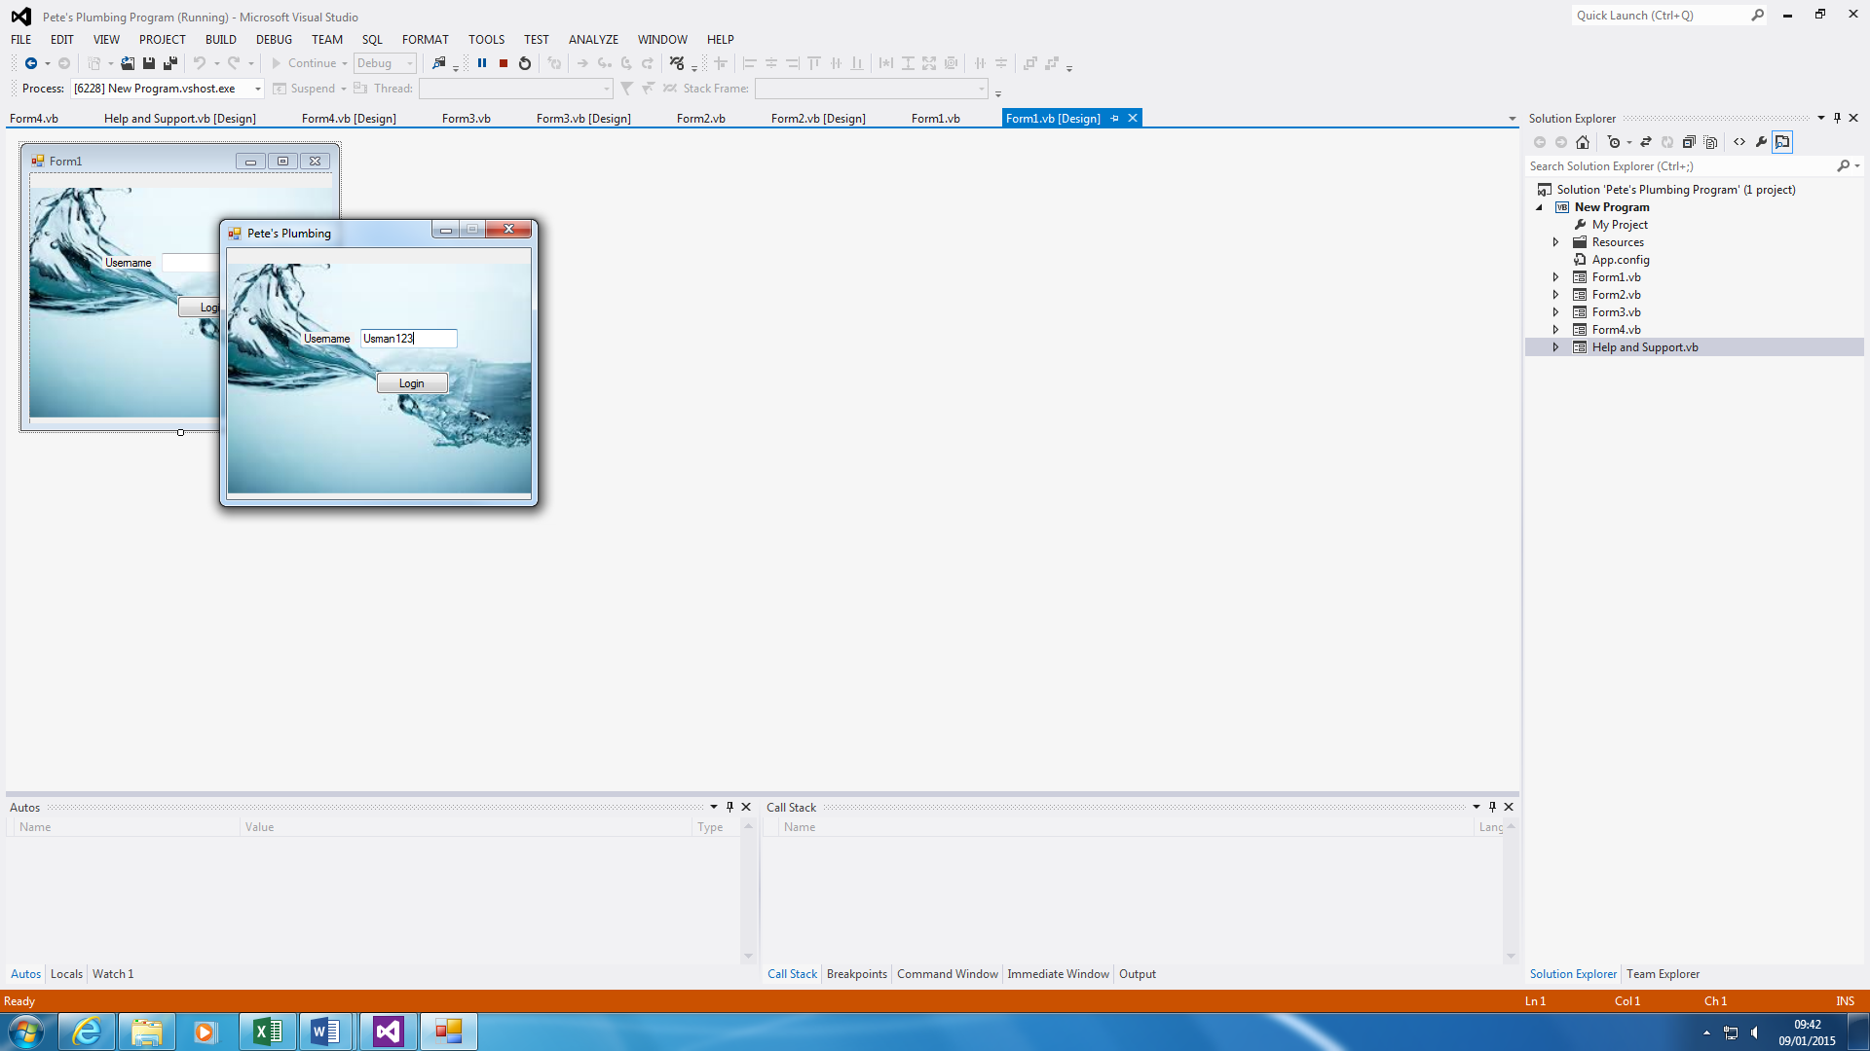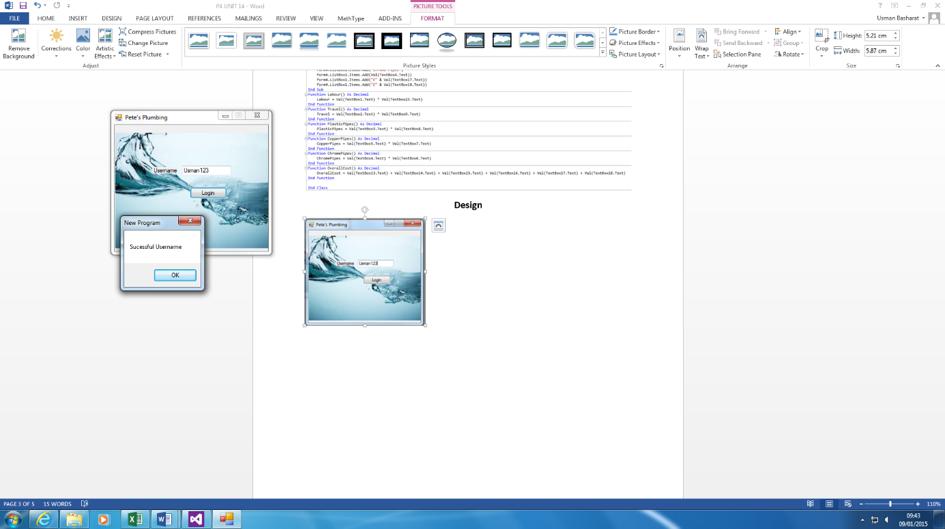**Login Screen**

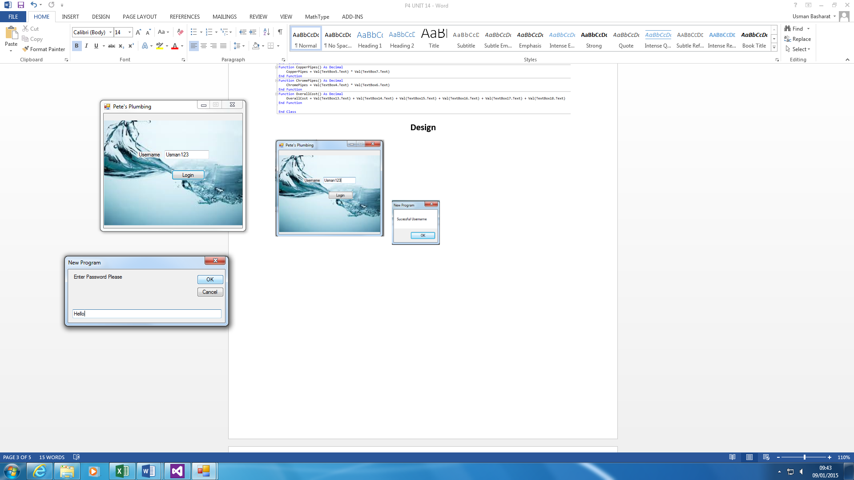



This is the login screen. As you can see, the username is typed in, and that needs to be correct in order to move on to the password. As you can see the code below, it shows how it works. The user will enter the username, “Usman123”, and password has to be correct in order show Form2.

**Block Header with Comments**

**Main Form**

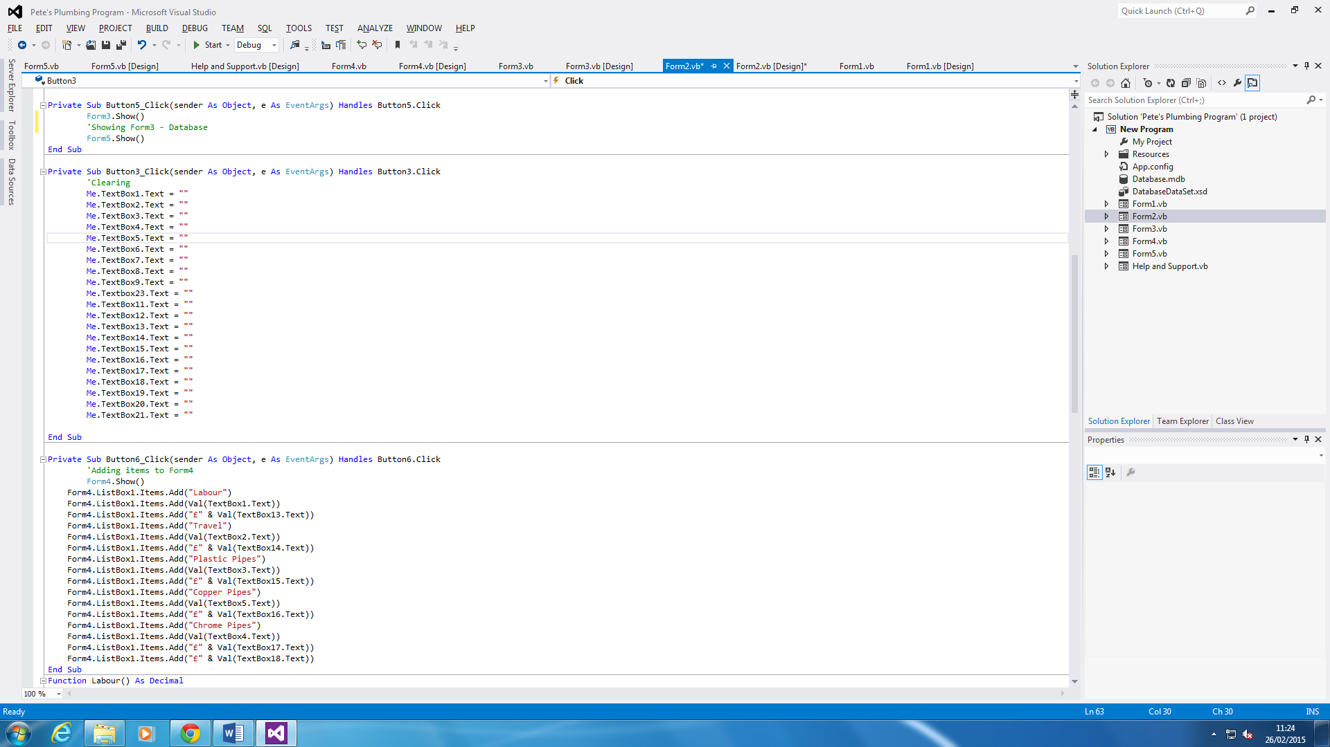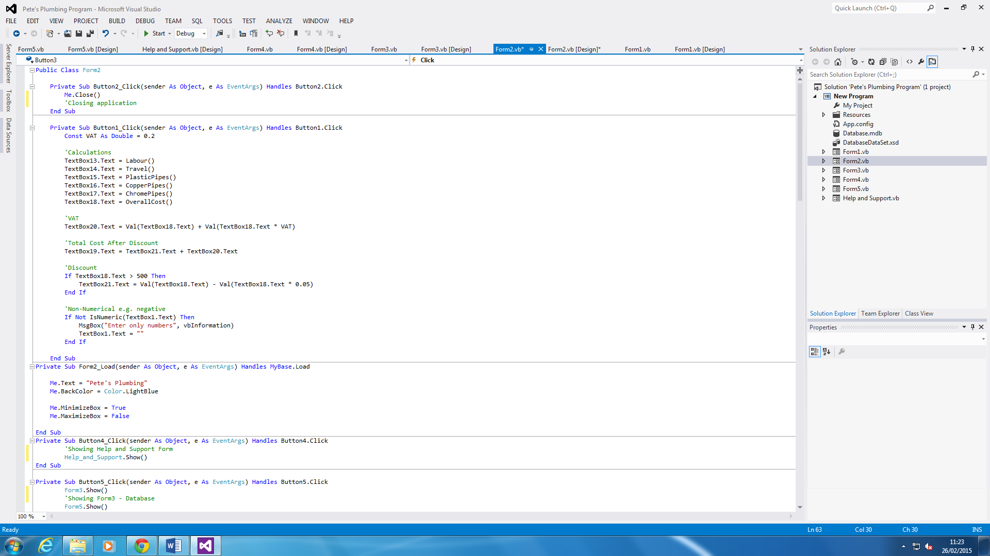

Figure 1.2

Figure 1.1

Figure 1.3

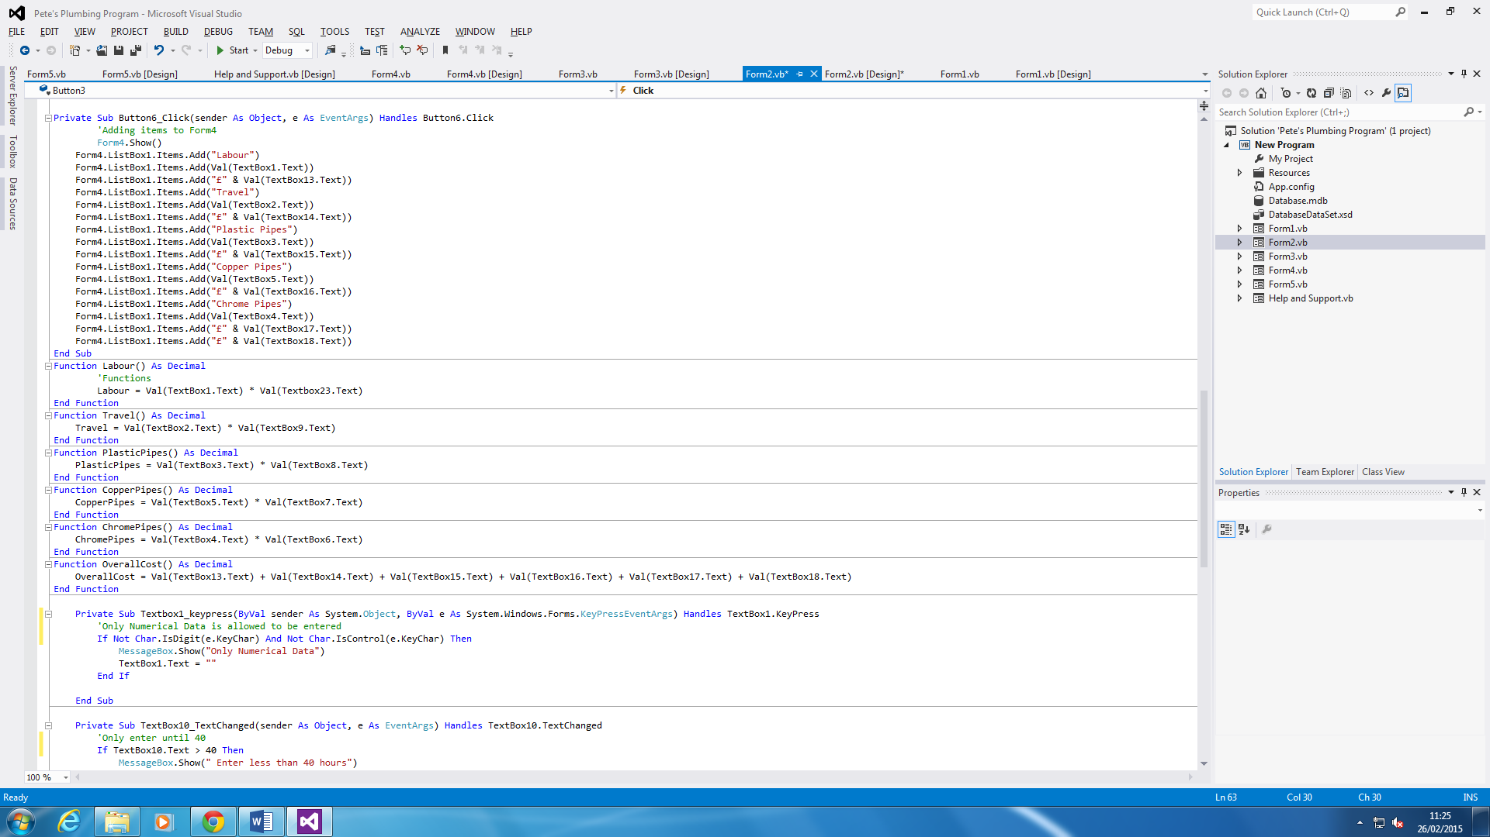

Figure 1.3

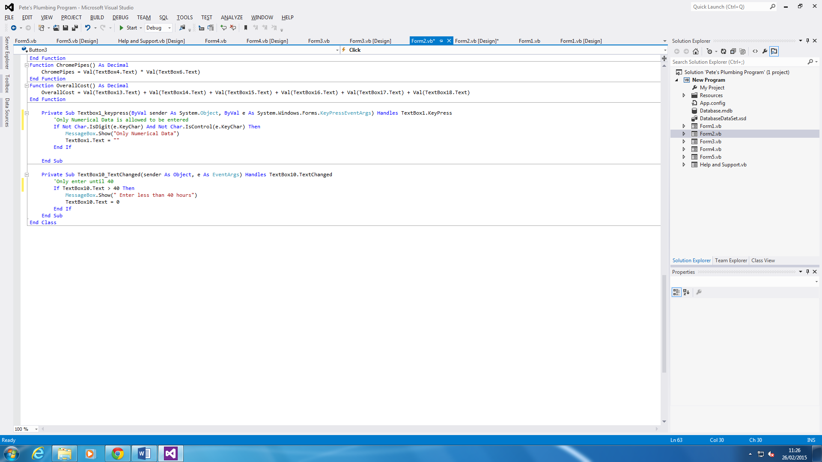

They are three pictures to show three parts of the whole code. Figure 1.1 shows us all the calculations and if anyone types in any negative, or anything apart from a number, it will show an error box; it will detect; and clear the box. Figure 1.2 shows us the customisations of the Main Form and once the clearing button is clicked, it clears all the textboxes. Figure 1.3 shows the summary code and the functions that I have used to put it in as a variable.

The last code, figure 1.4, shows that if Textbox1 has entered not a numerical data, a message would appear. The second one shows a limit to what the user can enter. This means, if the user wants to enter 45 hours within Hourly Rate, a message would appear saying, “Enter less than 40 hours”.

Figure 1.4

**Login Screen**

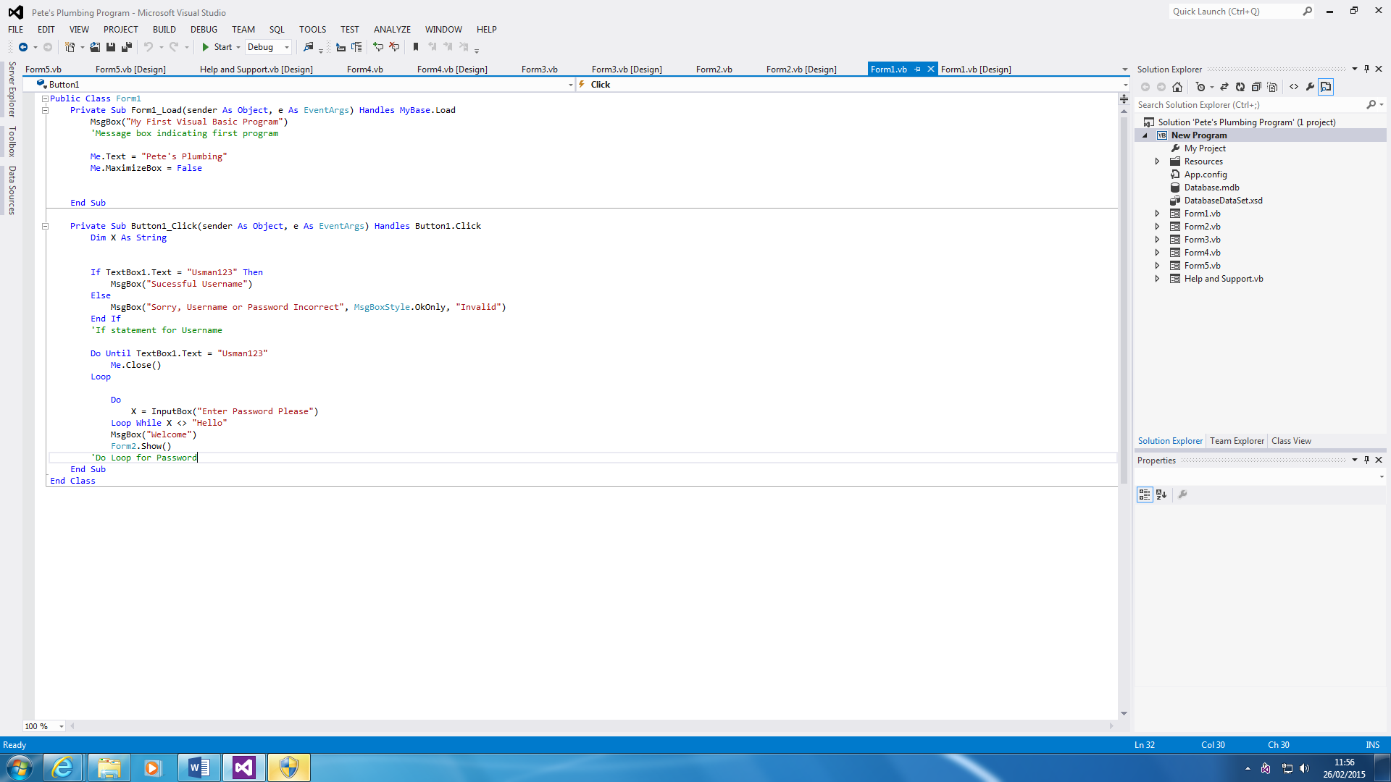

This is the Login Screen code. As you can see, the first part of the code is a message box with a personal touch. The second section is the code for the password. The ‘IF’ statement is for the Username and the ‘DO Loop’ is for the password.

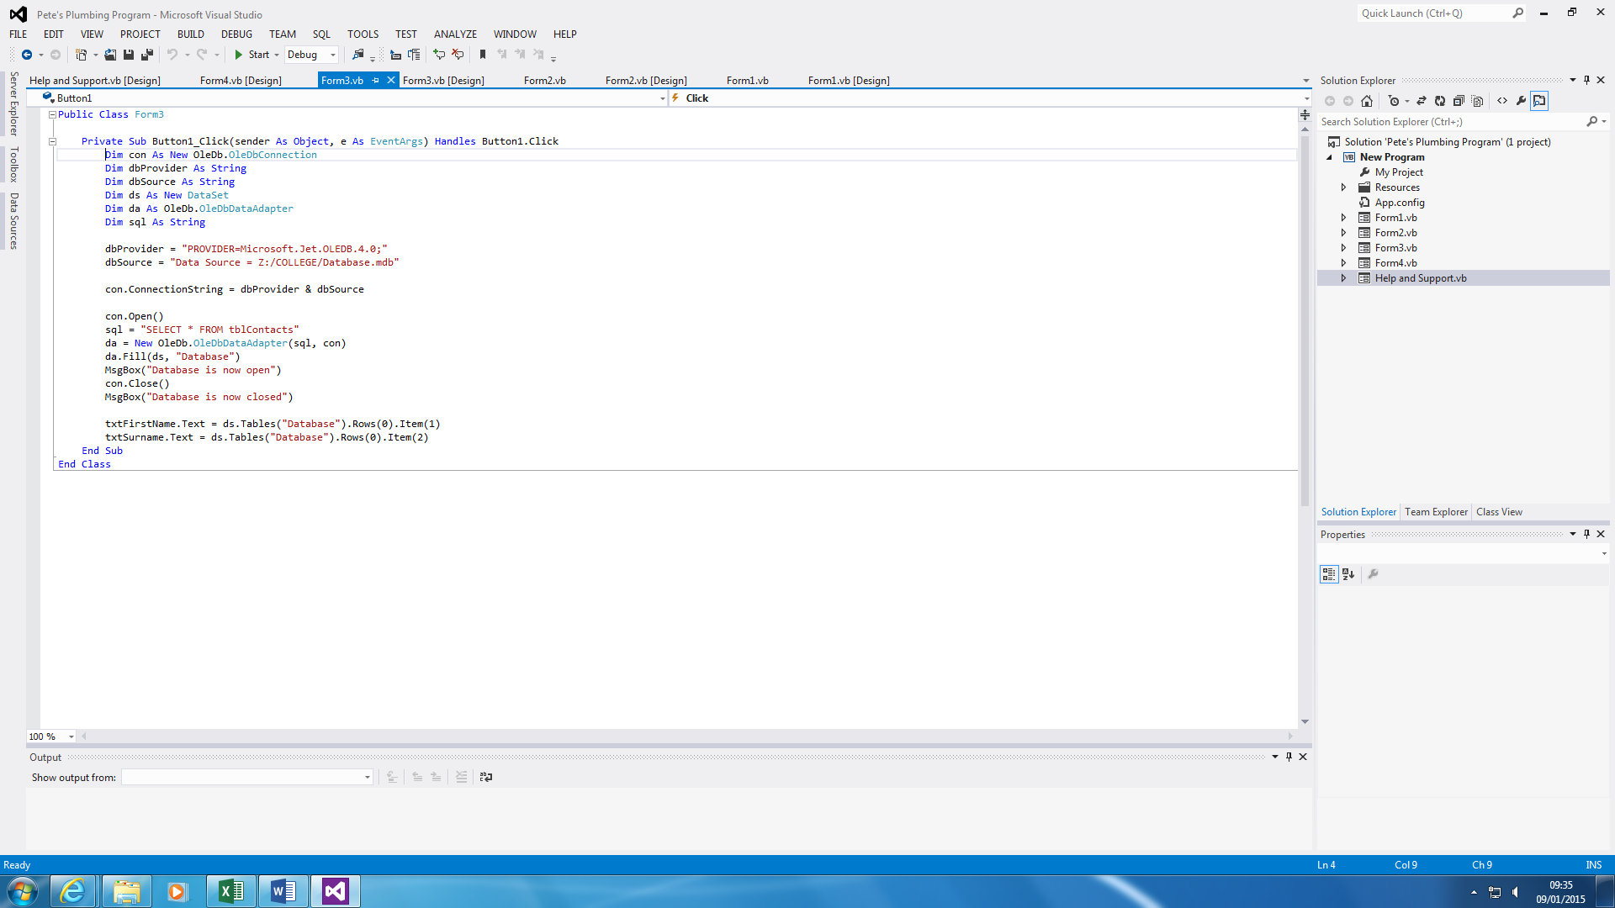

This is the database code. It shows that it needs to be connected with the database, locate it, and for it to be open and close in order to work.

**Data Declaration**



The purpose of this is for the X to be represented as the password. String is used so that the user can type in anything with 2 billion Unicode characters to choose from.



The functions is used to declare what is used within the calculations. All of them use Decimal as numbers is inserted within the Textboxes.



VAT is declared as a Constant, because it is fixed. For this program, the VAT is fixed at 20%, which is why I put 0.2. As you can see within the last code of it, I put VAT, so it is already declared.

**D2 – Evaluate an event driven application**

**Introduction**

In this report, I will be evaluating whether I have met the requirements. I will say what improvements I will need to make for my event driven application.

**Requirements**

These are the requirements that were set at the beginning of the project. This is the scenario that we have followed in order for the design that I have made to be make. To summarise, the user has a manual system and in order to improve it, he needs a program that does it for him. The code of the job is highlighted.

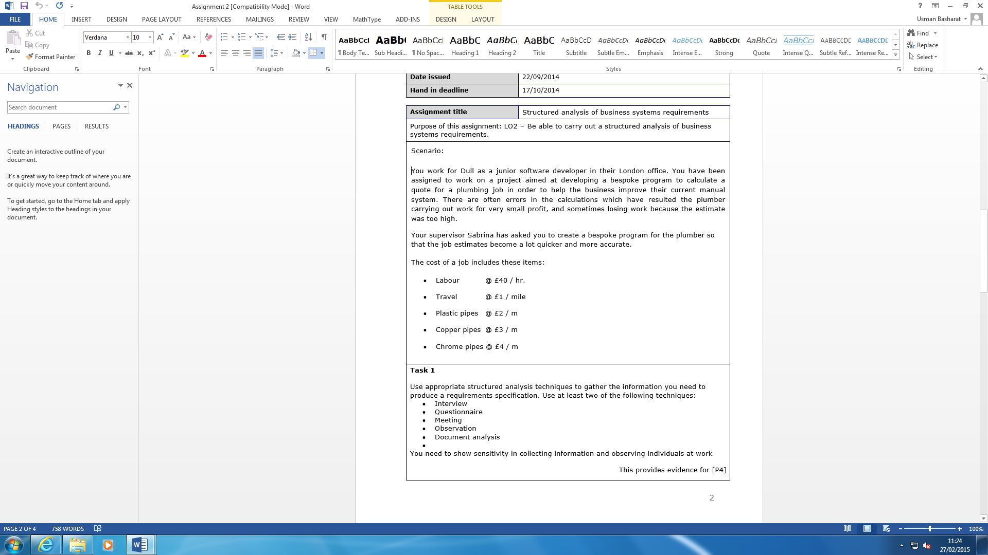

Figure 1.1

In order for these to be satisfied, the user needs to enter how many items they would like in order for the total cost to calculate. As you can see, the Main Form is below. This is where the user would be referred to once the Login is complete. The black highlighted border on Figure 1.1 are the other features on the application. The requirements have been met, because the issues, e.g. making mistakes, have been solved.



**Input**

The input that is included within the system would be for the user to include what he needs to calculate. For example, 10 pipes and hammer. The inputs that are required for the user to put in to the program is the Labour, Travel, Plastic Pipes, Copper Pipes, and Chrome Pipes. These necessary for the user to fill in. The program does not accept numbers, nor negative integers that is inserted within the Textboxes. The screenshot below shows how it will be at the start. You need to start filling it in for the input.



**Process**

The process would be for the calculations to be complete. This would erase any errors that the plumber has. This is only processed by the input being inserted. Once this is complete, the ‘calculate’ button needs to be clicked. This is complete automatically. This meets the requirement by preventing. The screenshot below shows that the user needs to fill it in for the process to be complete.





**Output**

The output would be the whole calculations complete. This meets the requirements that has been set in the scenario. The process and input needs to be complete. This means that there is only numbers inserted in the input. Otherwise, a message would appear and it would say enter only numbers. It would clear it. Once it has been all filled, as the image shows, you click the ‘calculate’ button and the output is complete.

**Design**

**Login Screen**

The Login Screen is simple and appealing. Referring to the images below, it has changed, because once I made my design; I wanted to put in both of the username and password together. I was able to do it too. However, I put a loop in to the password. Therefore, I had to change it by putting it separate. The design has not changed at all. This was made for security purposes. If anyone tried to get in to the system, they would need to use the same username and password to get in to the system.

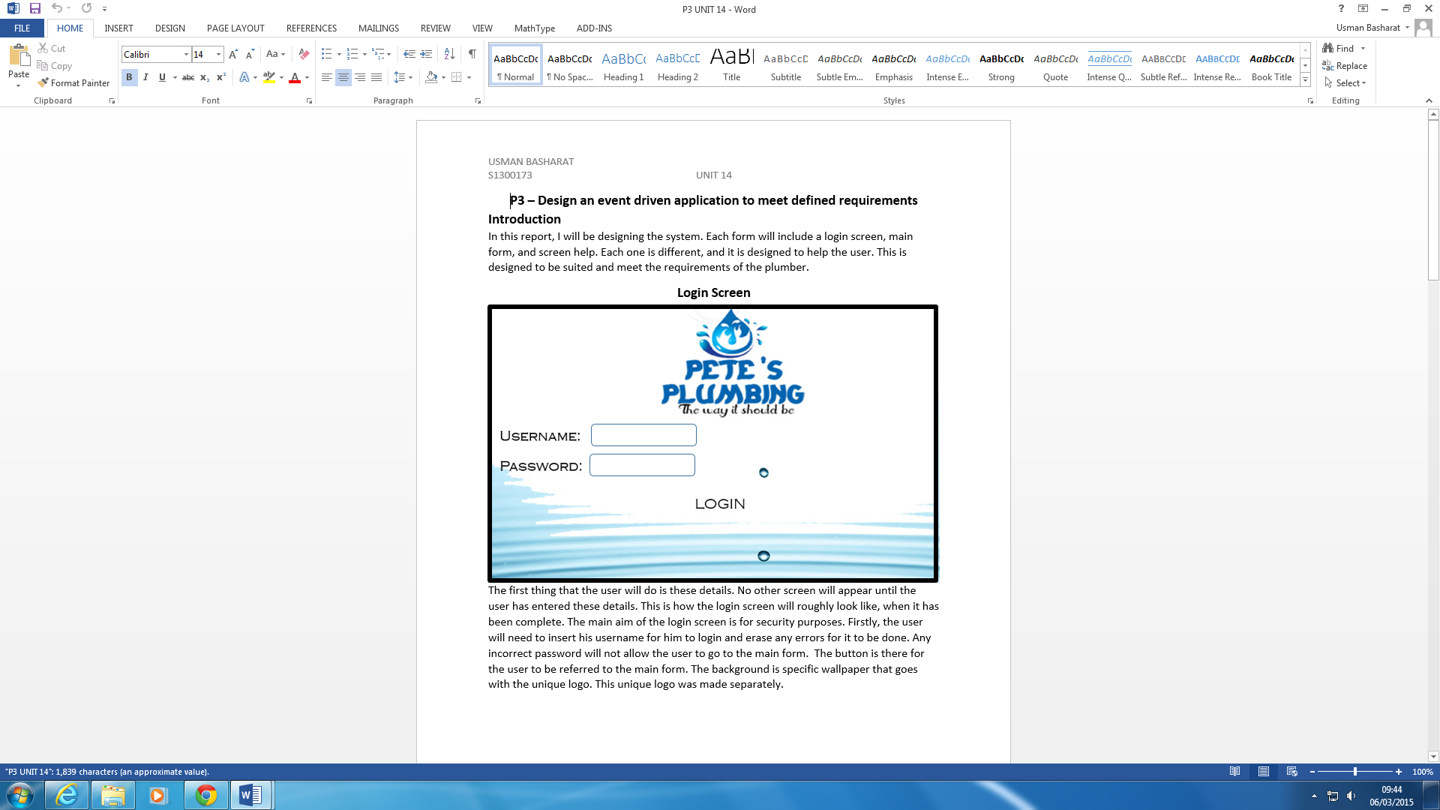

**Main Form**

The main form is slightly different to how I initially planned it to be. I had put in three buttons, but I realised, that more needed to be put in. I had the calculations part more to the central than I did. However, I decided later that I needed to put in Overall Cost with the rest of them. I added the EmployeeName and Number as an extra touch. Referring to the images below, you can see the changes is huge.

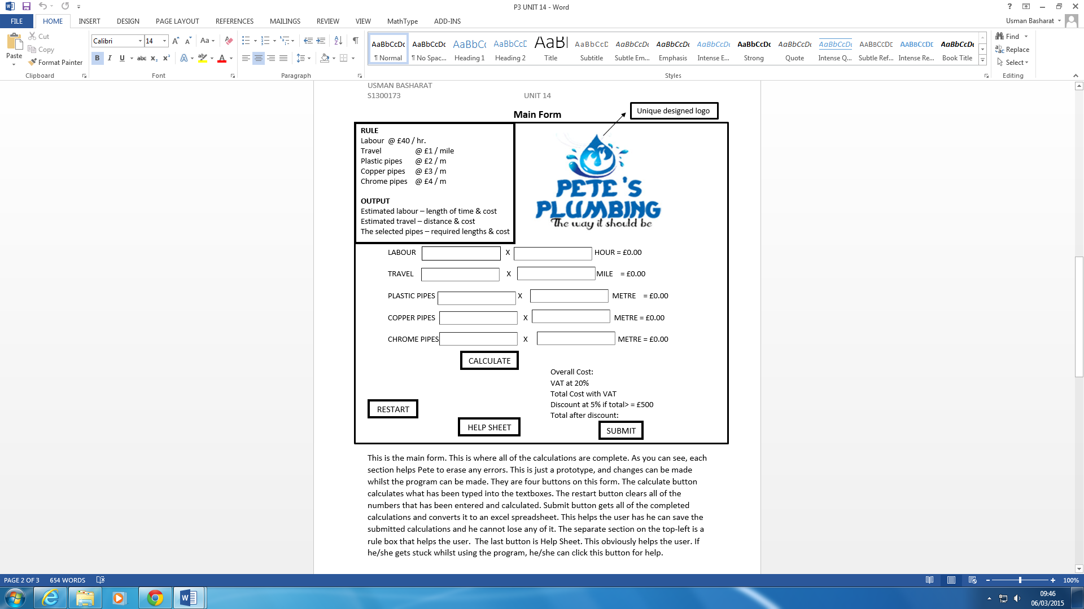



**Further Development**

The improvements that I will like to make on this program is that the security at the Login Screen can be improved. I feel that there can be many improvements to make this program better than it is initially. I suggest we can at in three attempts to try to get in to the system. This can prevent unauthorised users gaining access. It will surely secure it. Second improvement is going to be complete by adding another form to the main form. The new form is going to replace the current database. The database is not going to be like linked with the Microsoft Access document. It will all be done by linking it with a class and adding the information on a list box by using Object Oriented Programming to do this.